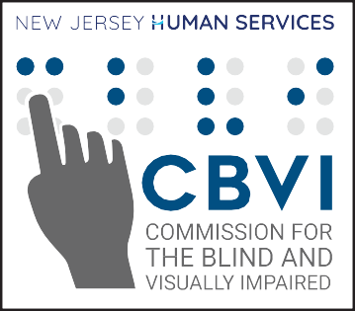

COUNTY | SITE ADDRESS | APPOINTMENT CONTACT | FIXED DAY/TIME
ATLANTIC | Southern Jersey Family Medical Center  1125 Atlantic Avenue  Atlantic City, NJ 08401 | 1-800-486-0131 | 3rd Monday, monthly  4PM - 7PM
ATLANTIC | Southern Jersey Family Medical Center  860 S. White Horse Pike  Hammonton, NJ 08037 | 1-800-486-0131 | 2nd Monday, monthly  6PM - 9PM
ATLANTIC | Southern Jersey Family Medical Center  932 S Main Street  Pleasantville, NJ 09232 | 1-800-486-0131 | 3rd Wednesday, monthly 5PM - 8PM
CAMDEN | Cherry Hill Free Clinic  5 Esterbrook Lane  Cherry Hill, NJ 08003 | Shimuna Afroja, MD  (856) 281-3032 | 4th Wednesday, monthly 1PM - 4PM
CAMDEN | Friends of Clementon Food Pantry  33 Berlin Road  Clementon, NJ 08021 | June  (856) 258-7318 | 4th Tuesday, even months 6PM - 9PM
CAMDEN | St. Joseph’s Neighborhood Center  904 N. 25th Street  Camden, NJ 08105 | Sara Navarro  (856) 338-8220 | 1st Wednesday, monthly 6PM - 9PM
CAPE MAY | Cape Volunteers in Medicine  423 Route 9 North  Cape May Court House, NJ 08210 | Anne Marie Jackson  (609) 463-2846 | 1st Monday, monthly 4:30PM - 7:30PM
CUMBERLAND | Capital Recovery Center  72 North Pearl Street  Bridgeton, NJ 08302 | Ashleigh Huff  (856) 459-3082 | 2nd Thursday, even months 3PM - 6PM
ESSEX | Saint John’s Soup Kitchen  22 Mulberry Street  Newark, NJ 07102 | Katie Shaw  (973) 220-0404 | 3rd Thursday, monthly 9:30AM - 12:30PM
ESSEX | Newark Emergency Services (NESF)  982 Broad St.  Newark, NJ 07102 | Markisha Deville  (973) 639-2100 ext 294 | 4th Thursday, monthly  9:30AM – 12:30PM
GLOUCESTER | Gloucester County Health Department  204 E. Holly Ave.  Sewell, NJ 08080 | Patty Thomas  (856) 384-6842 | 2nd Wednesday, monthly 5PM - 8PM
HUDSON | Save Latin America  138 39th Street  Union City, NJ 07087 | Lisette Serrano  (201) 271-7474 | 2nd Friday & 4th Tuesday, monthly  9:30AM - 12:30PM
HUNTERDON | Hunterdon County Dept. of Health  1 Walter E Foran Boulevard  Flemington, NJ 08822 | Shu Chiang, RN, BSN  (908) 806-4570 | 4th Thursday, monthly  3PM - 6PM
MERCER | Catholic Charities El Centro  327 South Broad St.  Trenton, NJ 08608 | (609) 394-2056 | 1st Tuesday, monthly 9:45AM - 12:45PM
MERCER | LALDEF  714-716 S. Clinton Avenue  Trenton, NJ 08611 | Caty  609-498-6839 | 4th Monday, monthly 9:30AM - 12:30PM
MIDDLESEX | New Brunswick Free Public Library  60 Livingston Ave.  New Brunswick, NJ 08901 | Maria Martinez/Kym  (732) 745-5108 ext 28 | 3rd Thursday, monthly  9AM - 12PM

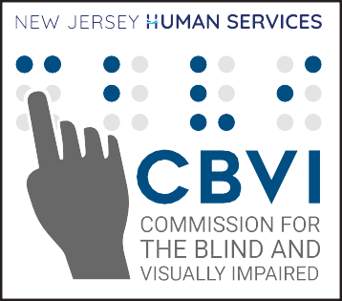
COUNTY | SITE ADDRESS | APPOINTMENT CONTACT | FIXED DAY/TIME
MIDDLESEX | Middlesex County Public Health Clinic  11 Kennedy Blvd  East Brunswick, NJ 08816 | (732) 745-3100 | 2nd Tuesday, monthly 9:30AM - 12PM
MIDDLESEX | PRAHD  357 New Brunswick Ave  Perth Amboy, NJ 08861 | Karina Garcia  (732) 638-2815 | 3rd Thursday, monthly  9AM - 12PM
MONMOUTH | CARC - Freehold  85 South Street  Freehold, NJ 07728 | 732-462-2666 | 1st Tuesday, monthly 9:30AM - 12:30PM
MONMOUTH | CARC - St. Peter Claver  1419 Springwood Avenue  Asbury Park, NJ 07712 | (732) 774-3282 | 3rd Tuesday, monthly 9:30AM - 12:30PM
MORRIS | Morris County Organization for Hispanic Affairs  87 Bassett Hwy  Dover, NJ 07801 | Lina Monsalve  (973) 366-4770 ext. 113 or 108 | 2nd Wednesday, monthly  9:30AM - 12:30PM
OCEAN | Volunteers in Medicine  730 Lacey Road  Forked River, NJ 08731 | (609) 384-0102 | 4th Tuesday  of odd months  3PM - 6PM
OCEAN | Ocean County Health Department  1771 Madison Avenue  Lakewood, NJ 08701 | Karen Barish  (732) 341-9700 ext 7604 | Call for appointment date 4PM - 7PM
OCEAN | Ocean County Health Department  175 Sunset Avenue  Toms River, NJ 08755 | Karen Barish  (732) 341-9700 ext 7604 | 2nd Thursday, monthly  4PM - 7PM
PASSAIC | Clifton Health Department  900 Clifton Avenue  Clifton, NJ 07013 | (973) 470-5758 | 2nd Thursday,  every other month  9:30AM - 12PM
PASSAIC | County of Passaic Department of Health  930 Riverview Drive, Suite 250  Totowa, NJ 07512 | Valentina Osorio/Genesis Moricete  (973) 881-4396 | 3rd Thursday & Last Wednesday, monthly  9:30AM - 12:30PM
PASSAIC | Clifton Health Department  207 Parker Avenue  Clifton, NJ 07013 | (973) 265-1533 | 2nd Thursday,  every other month  9:30AM - 12PM
SALEM | Southern Jersey Family Medical Center  238 East Broadway  Salem, NJ 08079 | 1-800-486-0131 | 1st Thursday, monthly  10AM - 1PM
SOMERSET | Safe Harbor Interim Program  87 E. High St.  Somerville, NJ 08876 | Tom O’Leary (908)393-9545 | 1st Thursday, monthly 9:30AM - 12PM
UNION | Linden Public Library  31 E. Henry St.  Linden NJ 07036 | (908) 298-3830 | 4th Thursday, monthly 9:30AM - 12:30PM
UNION | Hope Clinic - Plainfield  Call for exact address/location | Hope Clinic  (732) 209-5638 | 9:30AM - 12:30PM

